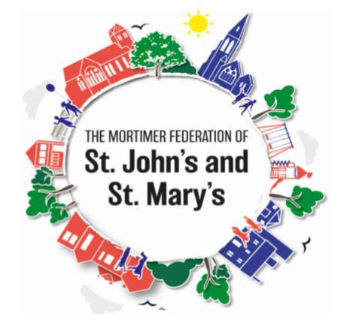
KS2 Assessment Information for Parents
If you have a child in year 6, at the end of key stage 2, they will usually take national curriculum tests in English grammar, punctuation and spelling, English reading and mathematics. The tests help measure the progress pupils have made and identify if they need additional support in a certain area. The tests are also used to assess schools’ performance and to produce national performance data. The key stage 2 tests will be taken on set dates unless your child is absent, in which case they may be able to take them up to 5 school days afterwards.
The 2021 KS2 SATs were due to start in the week commencing 10th May 2021 but due to circumstances surrounding Covid-19 Gavin Williamson (the Education Secretary) announced that these tests will be cancelled.
However, for us to ensure accurate information is passed on to your child’s new secondary school we will be undertaking both formal and informal assessments of your child’s attainment and progress in reading, grammar, punctuation and spelling, mathematics and science in the Summer term.
In terms of formal assessments, we will as a school be completing past SAT papers in English grammar, punctuation and spelling, English reading and mathematics 14th June 2021.
Here is an example timetable of how we will organise the week:
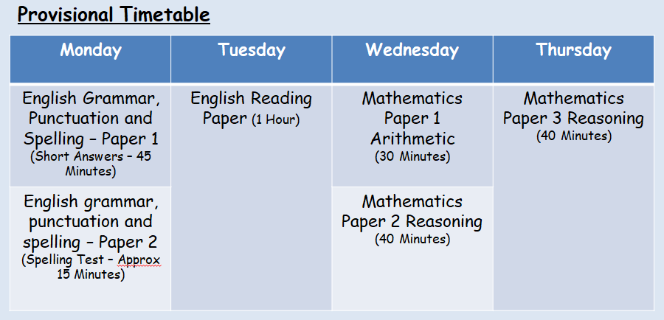

Teacher Assessment
As there is no test for English writing, this will be reported as a teacher assessment judgement. This is a judgement class teachers will make, based on your child’s work at the end of key stage 2. You will also receive a teacher assessment judgement for science.

Key Stage 2 Grammar, punctuation and spelling
The grammar, punctuation and spelling test consists of two parts: a grammar and punctuation paper requiring short answers, lasting 45 minutes, and a spelling test of 20 words, lasting around 15 minutes.
The grammar and punctuation test will include two sub-types of questions:
- Selected response, e.g. ‘Identify the adjective in the sentence below’.
- Constructed response, e.g. ‘Correct/complete/rewrite the sentence below’ or ‘The sentence below has an apostrophe missing. Explain why it needs an apostrophe.’

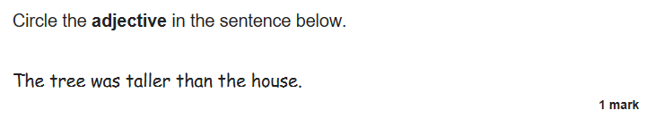
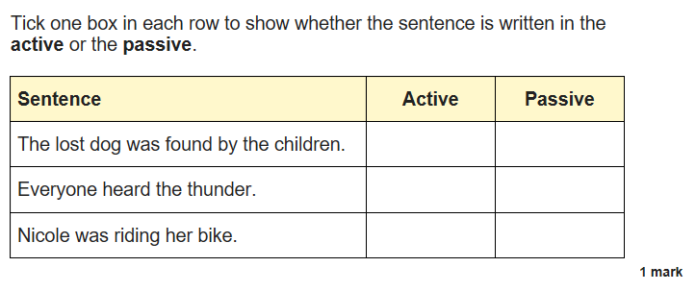
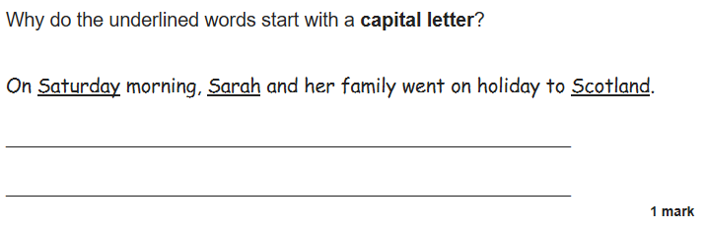
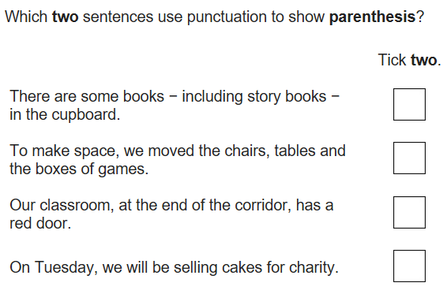

Key Stage 2 Reading
The reading test is a single paper with questions based on three passages of text.
Your child will have one hour, including reading time, to complete the test.
There will be a selection of question types, including:
- Ranking/ordering, e.g. ‘Number the events below to show the order in which they happen in the story’.
- Labelling, e.g. ‘Label the text to show the title of the story’.
- Find and Copy, e.g. ‘Find and copy one word that suggests what the weather is like in the story’.
- Short constructed response, e.g. ‘What does the bear eat?’
- Open-ended response, e.g. ‘Look at the sentence which begins . . . How does the writer build tension in this paragraph? Explain fully, referring to the text in your answer.
The reading content of the KS2 SATs will be more closely linked to the curriculum to ensure children are drawing on their knowledge when answering reading comprehension questions.
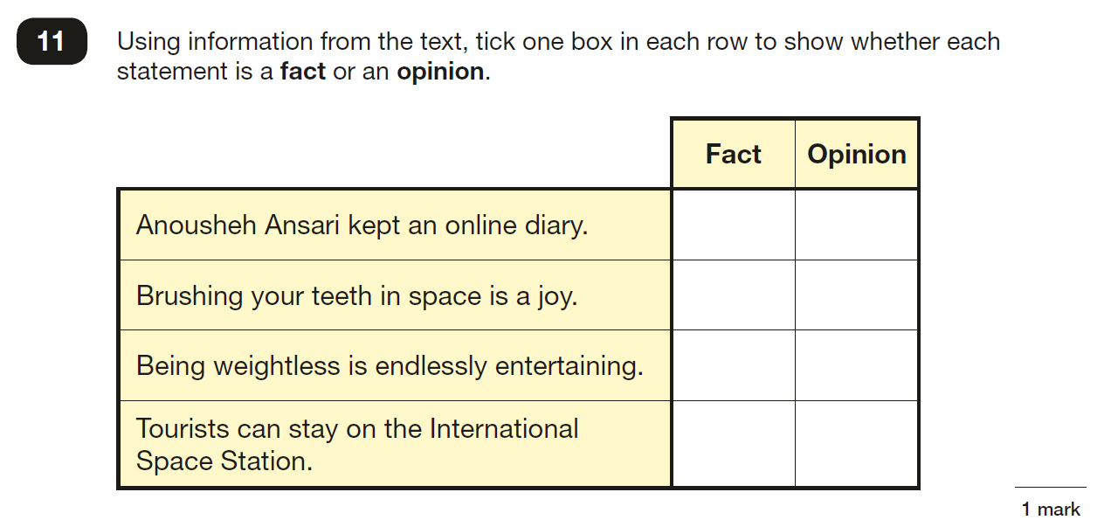

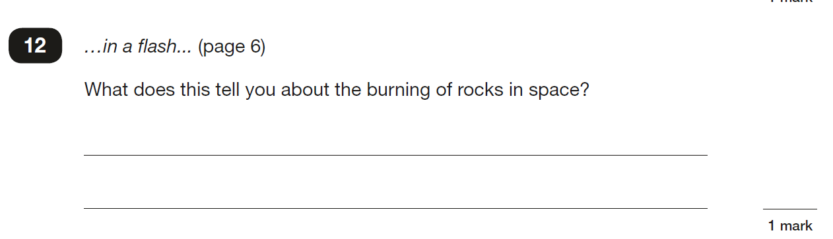

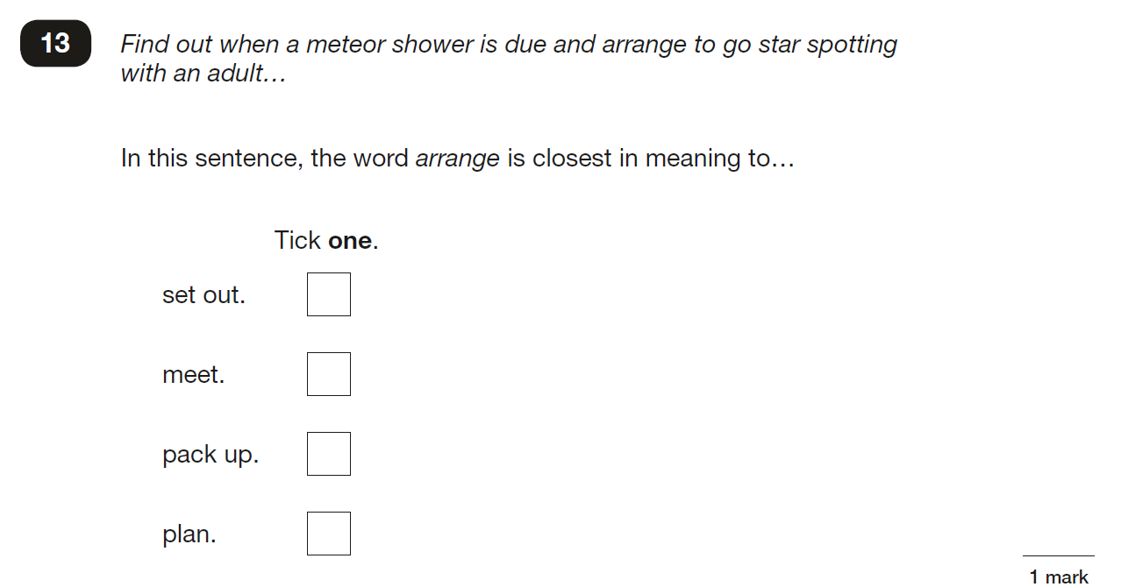

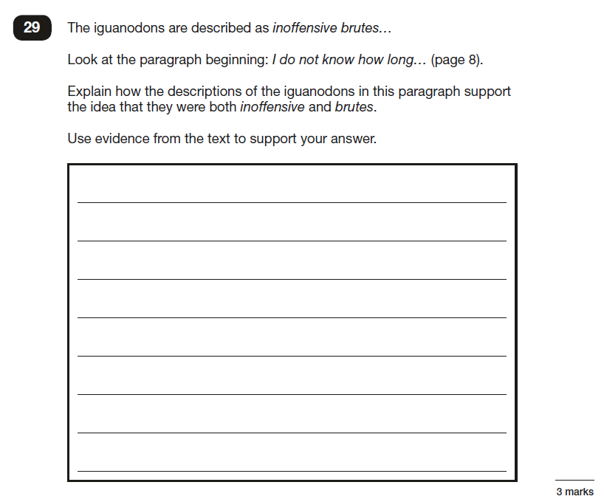

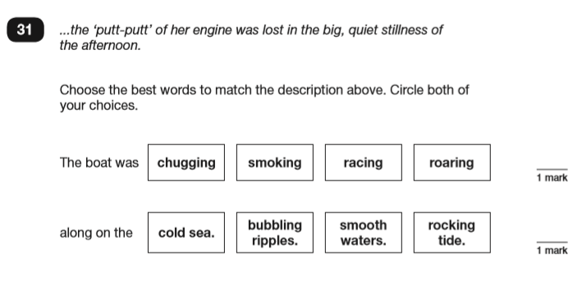

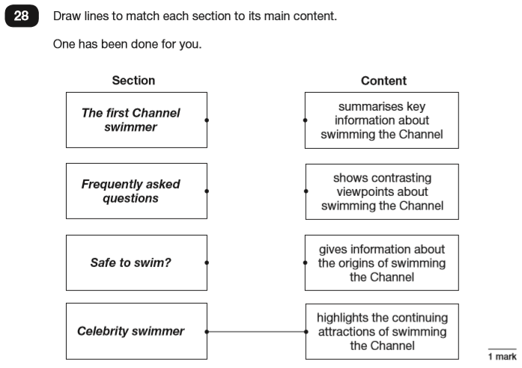

Key Stage 2 Maths
Children sit three papers in maths:
Paper 1 Arithmetic – 30 Minutes
Paper 1 will consist of fixed response questions, where children have to give the correct answer to calculations, including straightforward addition and subtraction and more complex calculations with fractions and percentages worth 1 mark each. The paper also covers long divisions and long multiplications worth 2 marks each.
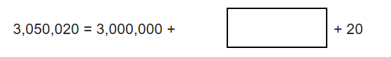
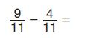

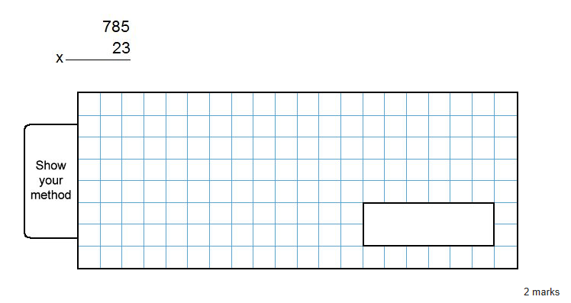

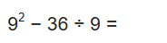
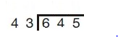

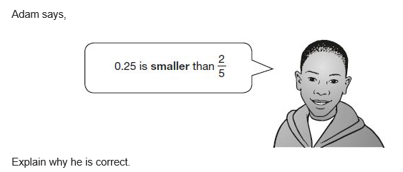

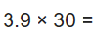

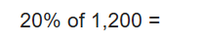

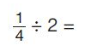
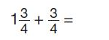
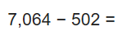

Papers 2 and 3 Reasoning – 40 Minutes each
Papers 2 and 3 will involve a number of question types, including:
- Multiple choice
- True or false
- Constrained questions, e.g. ‘Giving the answer to a calculation, drawing a shape or completing a table/chart/graph.
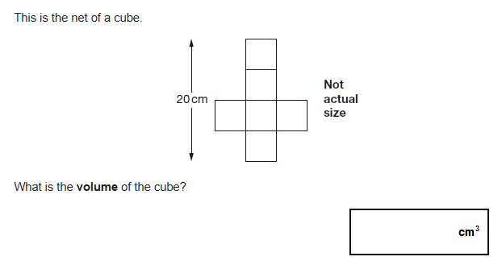
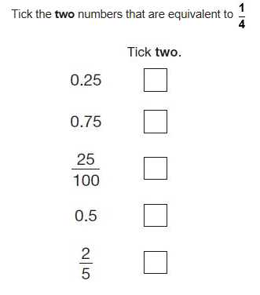
- Less constrained questions, where children will have to explain their approach for solving a problem.

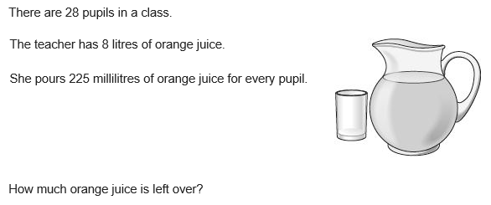

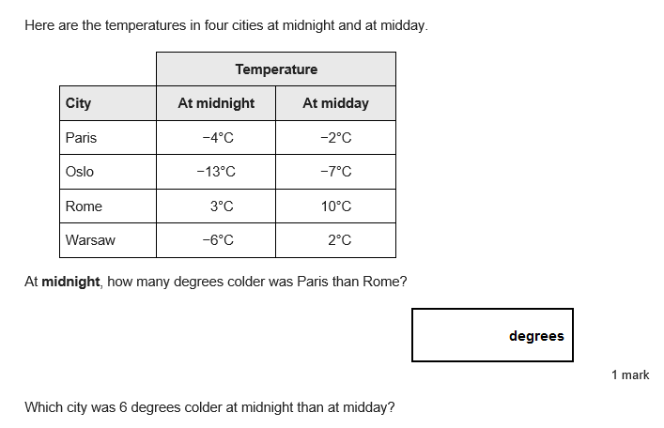

How will the tests be marked?
You will be given your child’s raw score (the actual number of marks they get), alongside their scaled score and whether they have reached the expected standard set by the Department for Education.
(‘NS’ means that the expected standard was not achieved and ‘AS’ means the expected standard was achieved).
The range of scaled scores available for each KS2 test is:
- 80 (the lowest scaled score that can be awarded).
- 120 (the highest scaled score)
The expected standard for each test is a scaled score of 100 or more.
If a child is awarded a scaled score of 99 or less they won’t have achieved the expected standard in the test.
The SATs tests are both set and marked externally.
Your child’s marks will be used in conjunction with teacher assessment to give a broader picture of their attainment.

Are there sample papers available?
Yes, sample papers can be found at the following links:
SPaG;
https://www.gov.uk/government/publications/key-stage-2-tests-2018-english-grammar-punctuation-and-spelling-test-materials
Reading:
https://www.gov.uk/government/publications/key-stage-2-tests-2018-english-reading-test-materials
Maths:
https://www.gov.uk/government/publications/key-stage-2-tests-2018-mathematics-test-materials

How can you support your child?
- Continue to support your child with class homework.
- Listen regularly to your child read.
- Don’t do too much! Despite all our efforts children can become anxious at this time. We will do all we can to alleviate this.
- If you have any questions/concerns please do not hesitate to contact your child’s class teacher.

